Library Management System
University of Mindanao Tagum College - Visayan Campus

A PROJECT PROPOSAL FOR PROFESSIONAL TRACK FOR IT13
PROFESSIONAL TRACK FOR IT4

SUBMITTED TO:
KATE STEFUNNY T. BRUNO

SUBMITTED BY:
PANCHO, ANGELI SOPHIA
TORAJA, ERHYL DEE
UY, JANNA VALERIE NICOLE

JANUARY 15, 2026

Table of Contents
Page
CHAPTER 1
INTRODUCTION
Project Context 1
Statement of the Problem 2
Objectives 3
General Objective 3
Specific Objectives 3
Scope and Limitations 4

CHAPTER 2
SYSTEMS DESIGN
Prototype 5
System Diagrams: 31
UML Class Diagram 31
Use Case Diagram 32
ERD (Entity Relationship Diagram) 33

CHAPTER 3
SYSTEM REQUIREMENTS
Functional Requirements 34
Non-Functional Requirements 35

References 36

CHAPTER 1

INTRODUCTION

Project Context
Libraries require reliable information systems to manage bibliographic records, circulation transactions, member eligibility, and policy enforcement. Manual and partially automated processes often lead to inconsistent records, delayed updates, and errors in tracking borrowed materials and overdue fines. Library Management Systems address these limitations by centralizing data, validating transactions, and enforcing predefined borrowing rules consistently across users (Soutron, 2020).
Studies on library automation show that integrated systems improve cataloging accuracy, circulation monitoring, and inventory control by reducing reliance on manual recordkeeping. Research published in the International Journal of Research in Library Science reports improved circulation and member record accuracy through structured workflows and centralized databases (Araya & Mengsteab, 2020). Similarly, systems that integrate cataloging, circulation, and fine management support reliable transaction tracking and reporting (Zunjar, Yadav, & Markad, 2020).
Effective Library Management Systems depend on sound software architecture. Applying object-oriented programming principles and modular design standards such as SOLID supports maintainability and controlled access to institutional data, which is necessary for systems managing long-term academic records (Martin, 2003).
In Philippine academic libraries, centralized systems aligned with institutional policies have been shown to improve circulation tracking, inventory visibility, and report generation. A study conducted at F.L. Vargas College documented improved operational monitoring following the implementation of a Library Management System (Pinto, 2024). Policy frameworks from the American Library Association are also used to guide borrowing rules, access control, and user accountability in library systems (American Library Association, 2020).
This project proposes a Windows Desktop Library Management System developed using C# .NET Framework and WinForms with a SQL Server backend. The system integrates member management, cataloging, circulation, reservation tracking, fine computation, inventory control, and reporting within a centralized database. Role-based access control restricts system functions by user role, while automated validation enforces borrowing limits, renewal rules, and penalty computation to support accurate and policy-compliant library operations.

Statement of the Problem
The University of Mindanao Tagum College Library experiences operational difficulties resulting from manual and partially automated processes. These difficulties include:
- Inaccurate circulation records caused by manual logging and delayed updates of borrowing and return transactions.
- Inconsistent enforcement of borrowing policies due to the absence of automated validation for member eligibility, loan limits, and renewal rules.
- Error-prone fine computation arising from manual calculation of overdue penalties and lack of centralized fine records.
- Limited inventory visibility in tracking multiple copies, shelf locations, and material conditions such as damaged or lost items.
- Restricted search functionality that prevents efficient retrieval of books and member records using structured criteria.
These issues indicate the need for a centralized Library Management System that automates core operations, enforces policies consistently, and maintains accurate and reliable library records.

General Objective
To design and develop a Windows desktop-based Library Management System using C# .NET WinForms that automates library operations, enforces borrowing policies, and improves record accuracy for the University of Mindanao Tagum College Library.

Specific Objectives
a. To implement role-based user and member management with controlled access to system functions.
b. To develop a cataloging module that stores complete bibliographic data and tracks multiple physical copies.
c. To implement circulation processes for borrowing, returning, and renewing materials with eligibility validation.
d. To design a fine and payment module that computes overdue penalties and records transactions accurately.
e. To provide a structured search interface for efficient retrieval of books and member records.
f. To apply object-oriented programming concepts and SOLID principles in system design.
g. To design a normalized relational database schema using SQL Server for reliable data storage.

Scope and Limitations
The project covers the development of a Windows desktop Library Management System using C# .NET WinForms and SQL Server. It includes user and member management, catalog management, circulation processing, fine and payment tracking, inventory monitoring, reporting, and advanced search functionality. The system supports role-based access for administrators and library staff and applies object-oriented design principles.
The system is limited to a Windows desktop environment and does not support web or mobile access. The system includes reservation management within system-defined rules but does not support external notifications or queue-based messaging. Payment processing is limited to internal recordkeeping and does not integrate with external payment gateways. Hardware integration such as barcode scanners is excluded from the project scope.

CHAPTER 2

SYSTEMS DESIGN
Prototype
This C# WinForms desktop-based Library Management System provides centralized control over core library operations. It integrates User and Member Management, comprehensive Cataloging, and full Circulation functions including borrowing, returning, and renewing materials.
The system supports Reservation Management, enforces library policies through automated Fine and Penalty calculations, and maintains accurate stock levels via Inventory Management. An integrated Reporting and Analytics module delivers essential insights on circulation, members, collections, finances, and operational statistics to support effective decision-making.
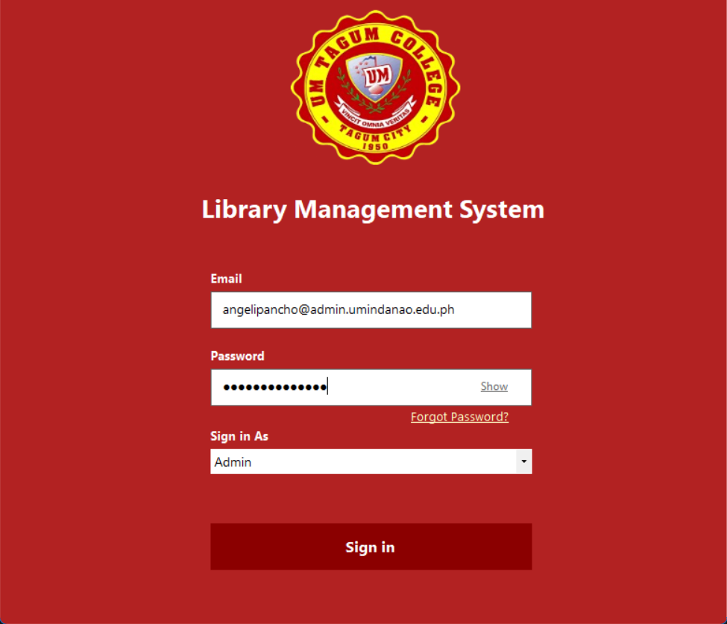
Figure 2.1 Login Page
Figure 2.1 illustrates the WinForms Login Page of the Library Management System, which supports role-based access control. Users are required to enter their Email and Password, then select their assigned role (Admin or Library Staff) from a dropdown menu to access the appropriate system features. The interface also includes a Forgot Password option, allowing users to reset their credentials by entering their registered email address.

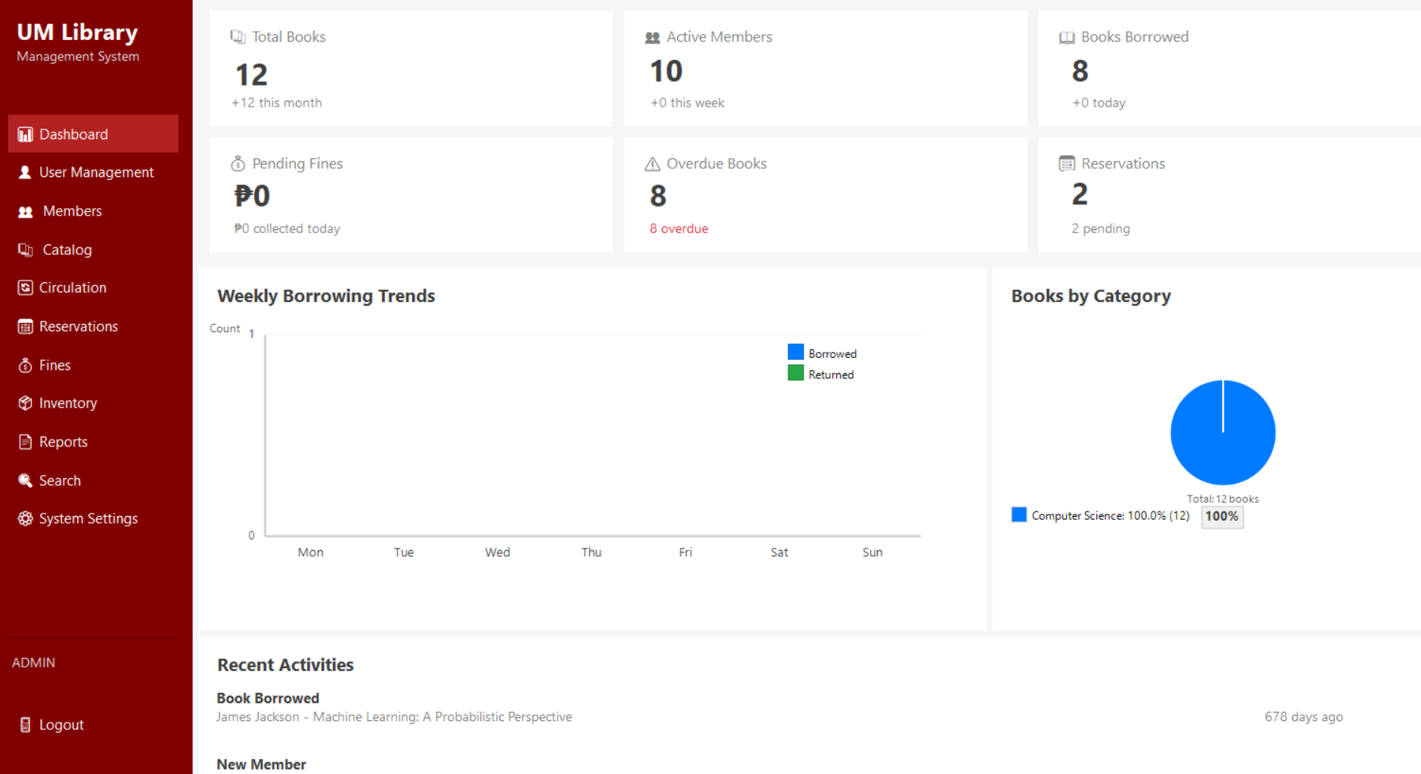
Figure 2.2 Admin Dashboard Page
Figure 2.2 Admin Dashboard Page displays an overview of the library’s operational status through key performance indicators, including total books, active members, books borrowed, pending fines, overdue items, and reservations. It features visual summaries such as weekly borrowing trends and books by category, enabling quick monitoring of circulation and collection distribution. The dashboard also includes a recent activities panel to track the latest system transactions, supporting efficient administrative decision-making.
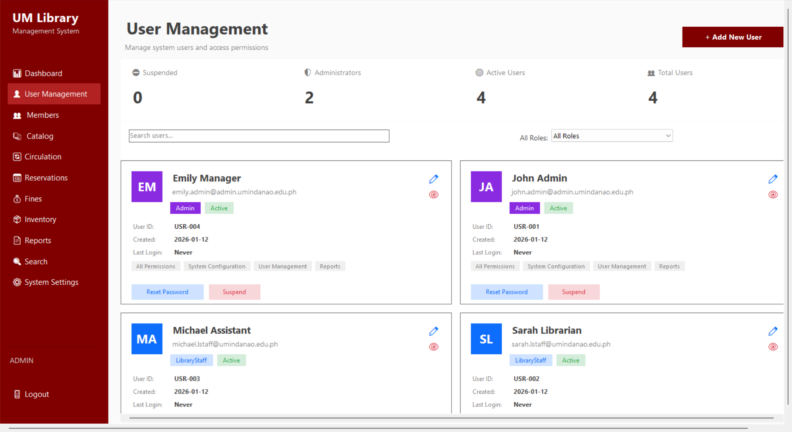
Figure 2.3 Admin User Management Page
Figure 2.3 Admin User Management Page provides administrators with centralized control over system user accounts and access permissions. It displays user status summaries (active, suspended, administrators, and total users) and supports searching and filtering by role. Administrators can add new users (Admin and Library Staff), view user details, assign roles and permissions, reset passwords, suspend accounts, and manage access rights to ensure secure and organized system operation.

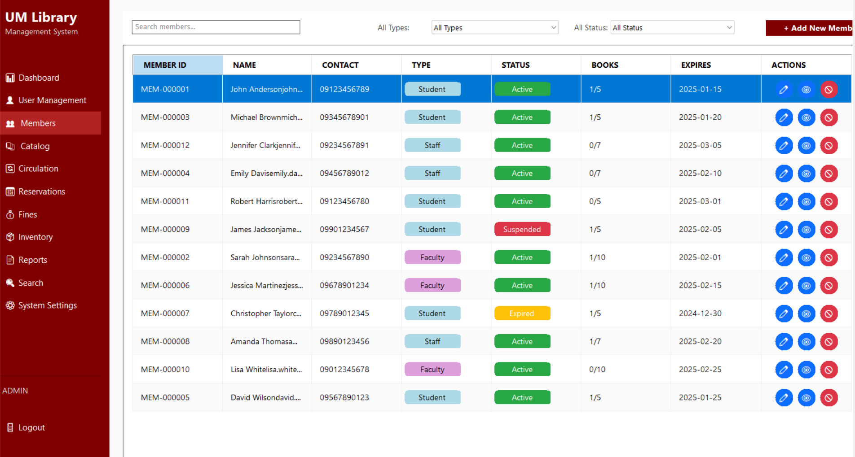
Figure 2.4 Admin Members Page
Figure 2.4 Admin Members Page enables administrators to manage registered library members efficiently. It displays member records including member ID, name, contact details, membership type, status, borrowing limits, and expiration date. The page supports searching, filtering by type and status, and provides action controls to view, edit, suspend, or manage member accounts, ensuring accurate member monitoring and policy enforcement.

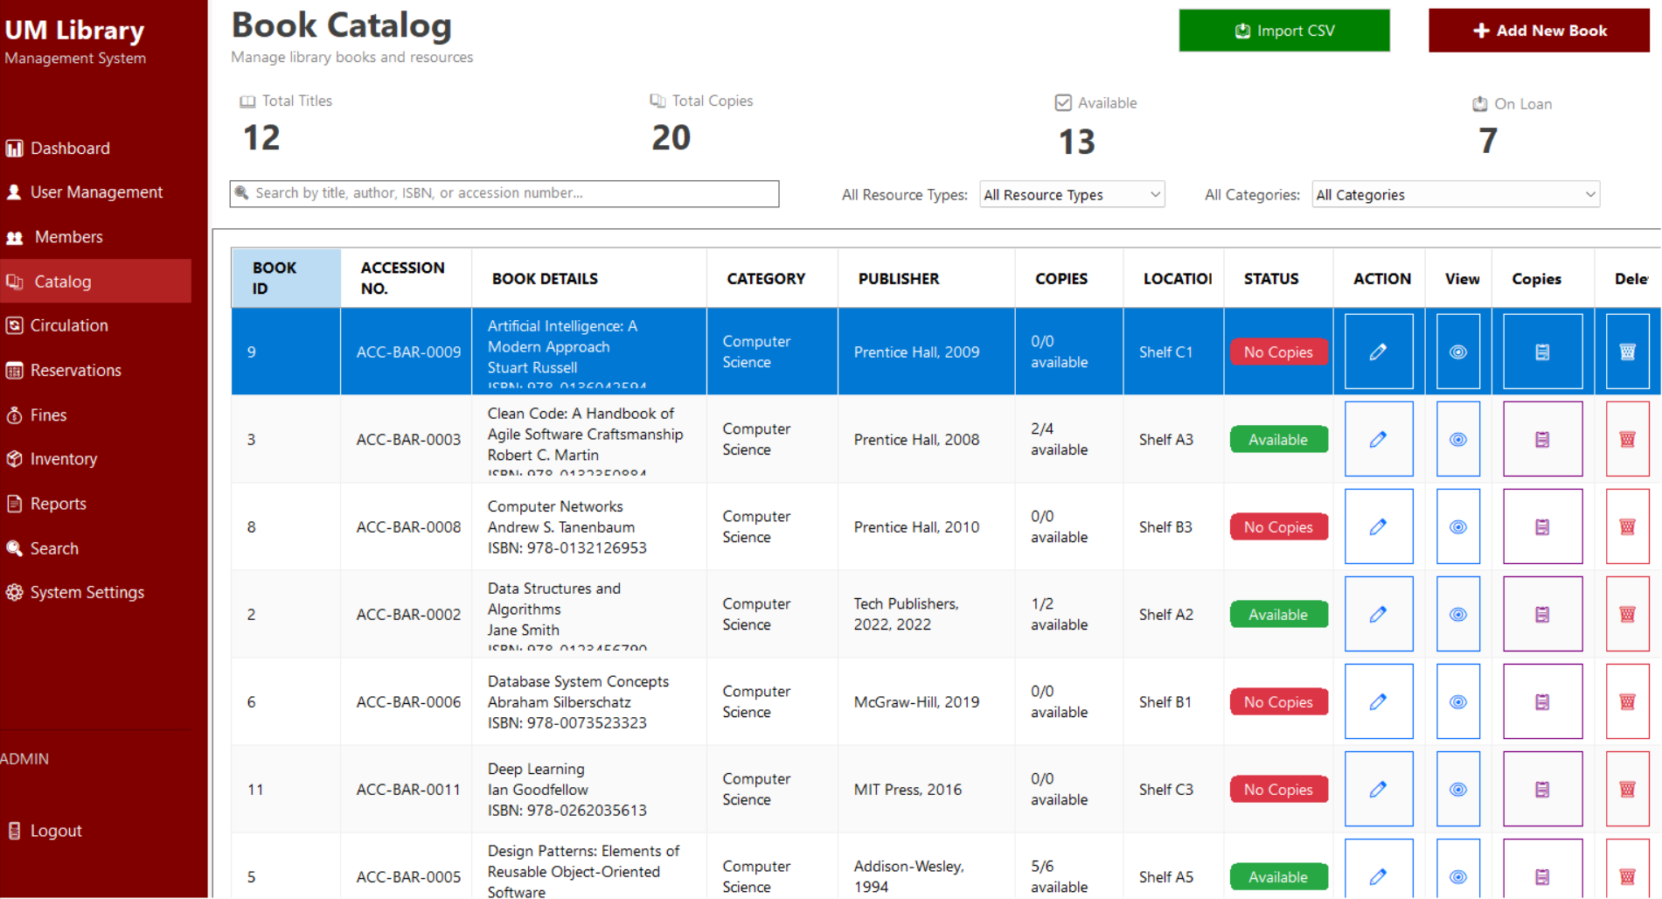
Figure 2.5 Admin Catalog Page
Figure 2.5 Admin Catalog Page allows administrators to manage the library’s book collection and resources. It presents summary indicators for total titles, total copies, available items, and books on loan, and provides tools for searching and filtering by title, author, ISBN, accession number, resource type, and category. The page supports adding and importing books, managing copies and locations, updating availability status, and performing view, edit, and delete actions, ensuring accurate and organized catalog maintenance.
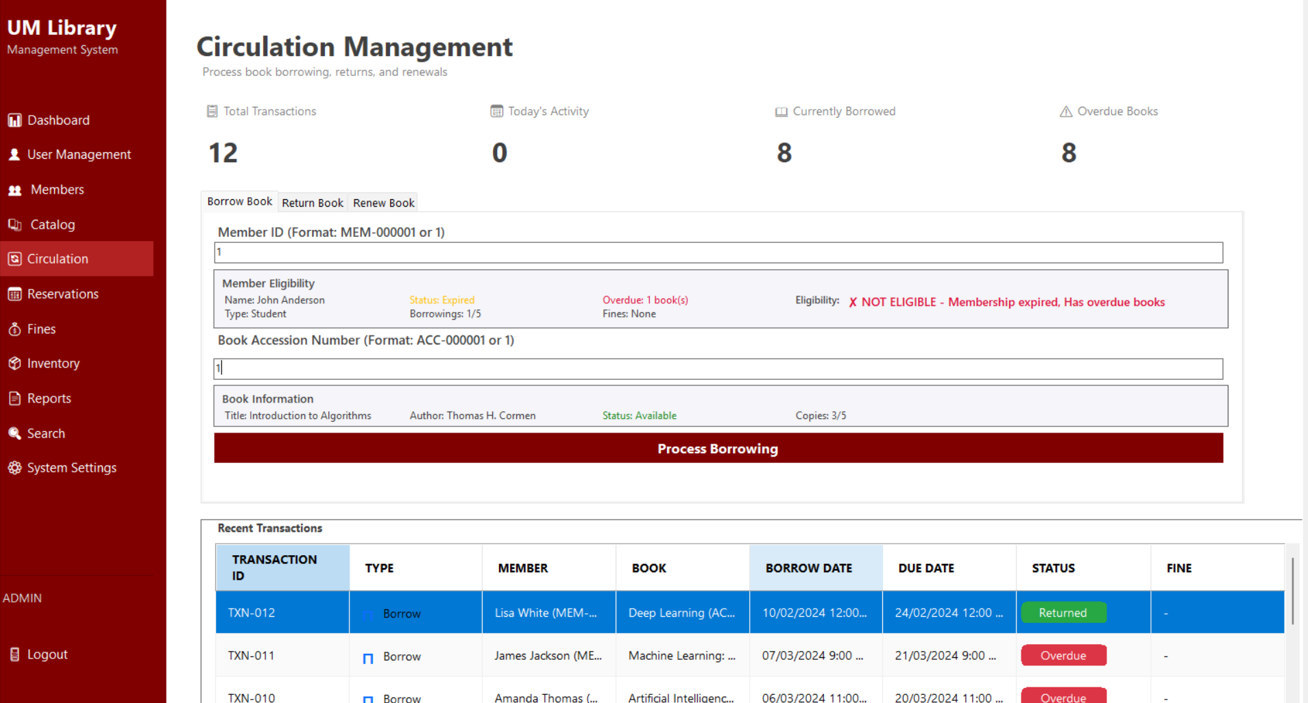
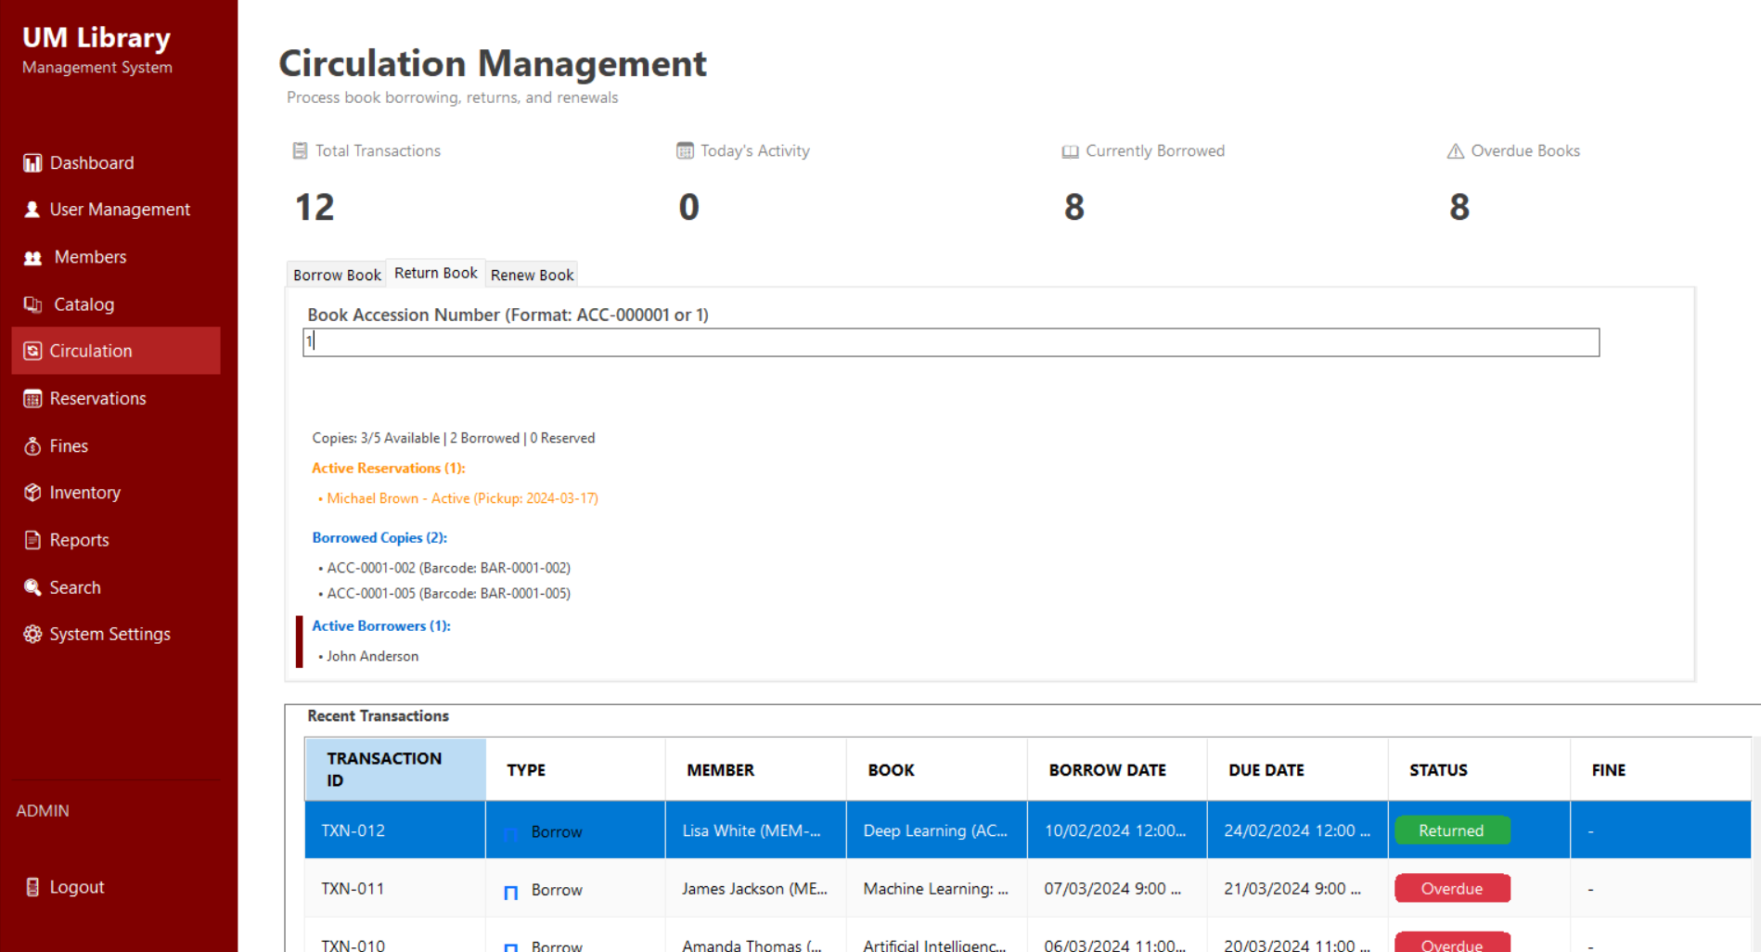
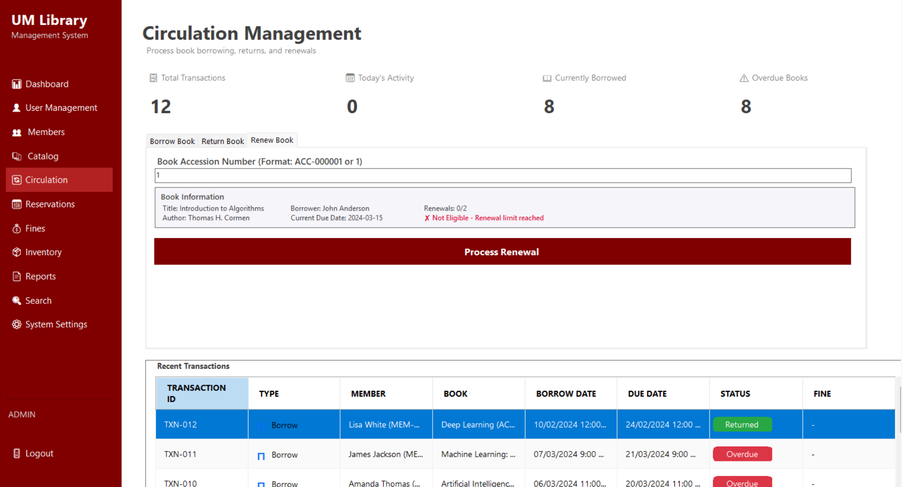
Figure 2.6 Admin Circulation Page
Figure 2.6 Admin Circulation Page facilitates the processing of book borrowing, returns, and renewals. It displays key circulation indicators such as total transactions, current borrowings, today’s activity, and overdue books. The page validates member eligibility, book availability, reservation status, and renewal limits before allowing transactions, and includes a recent transactions list to ensure accurate tracking and enforcement of circulation policies.

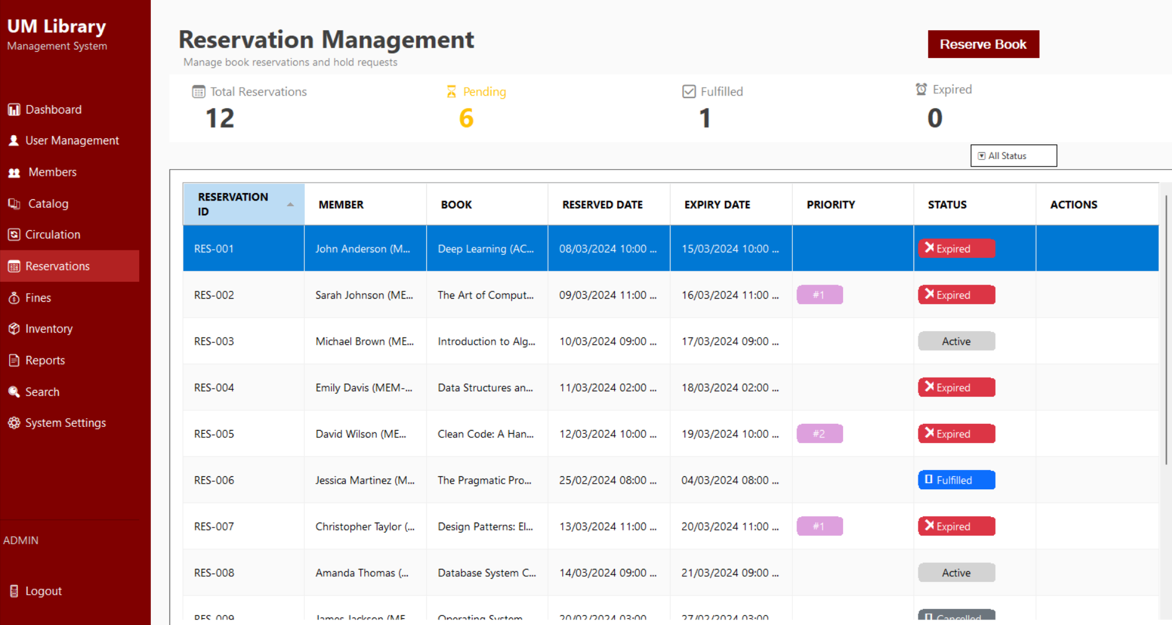
Figure 2.7 Admin Reservation Page
Figure 2.7 Admin Reservation Page manages book reservations and hold requests. It displays reservation summaries including total, pending, fulfilled, and expired reservations, and lists detailed records with member information, reserved books, reservation and expiry dates, priority order, and status. The page supports filtering by status, priority handling, and reservation processing, ensuring fair queue management and timely fulfillment.

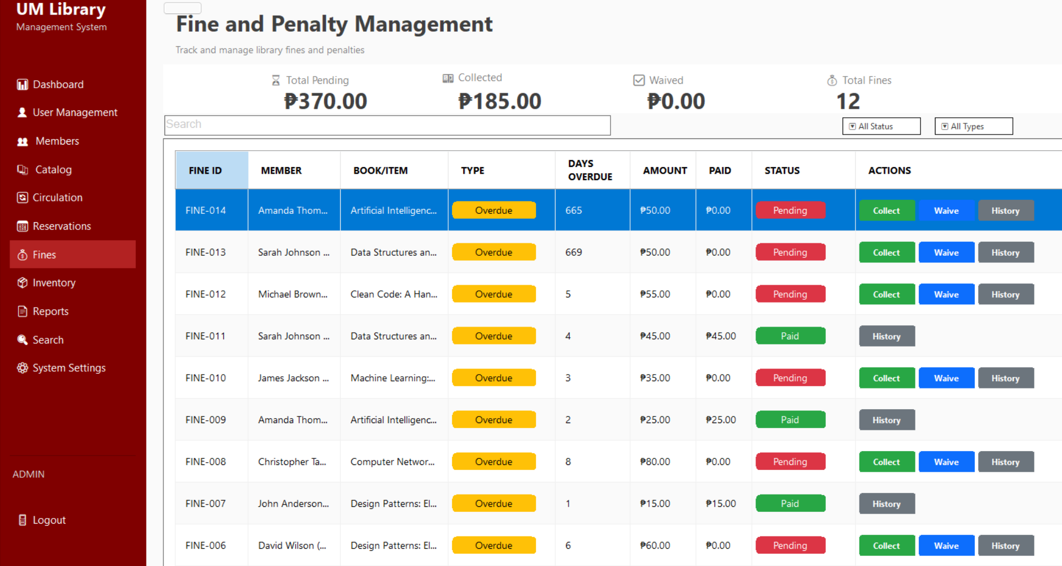
Figure 2.8 Admin Fines Page
Figure 2.8 Admin Fines and Penalty Page enables administrators to track, manage, and enforce library fines and penalties. It presents financial summaries including total pending, collected, waived fines, and total fine records, and displays detailed entries with member information, overdue duration, fine type, amount, payment status, and actions. The page supports fine collection, waiving, and history viewing, ensuring transparent and consistent policy enforcement.

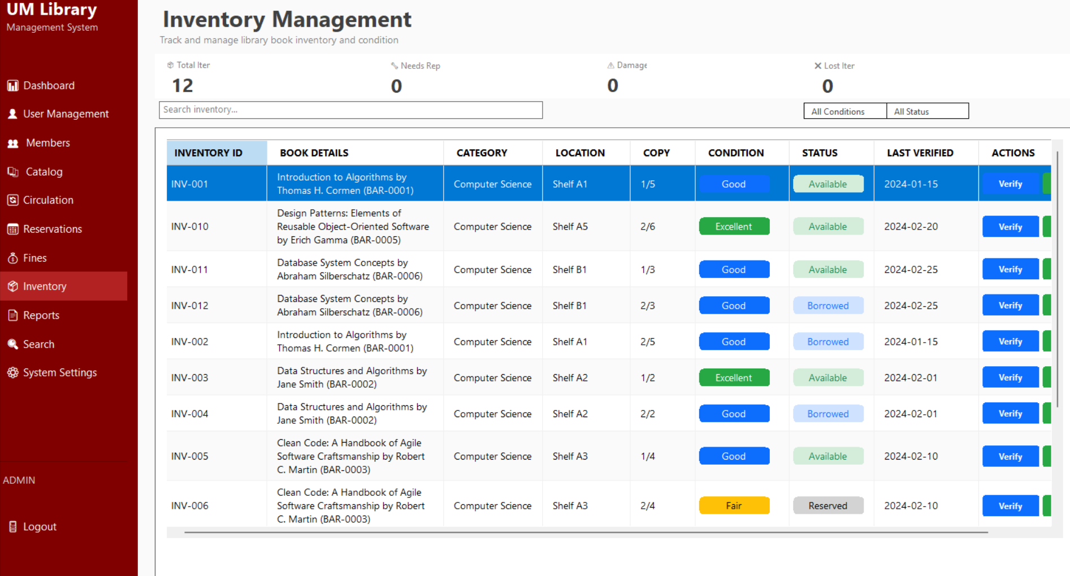
Figure 2.9 Admin Inventory Page
Figure 2.9 Admin Inventory Page enables administrators to track and manage library inventory and item conditions. It displays inventory summaries such as total items, items needing repair, damaged items, and lost items, along with detailed records showing book information, category, location, copy count, condition, availability status, and last verification date. The page supports inventory verification and updates, ensuring accurate stock control and condition monitoring.

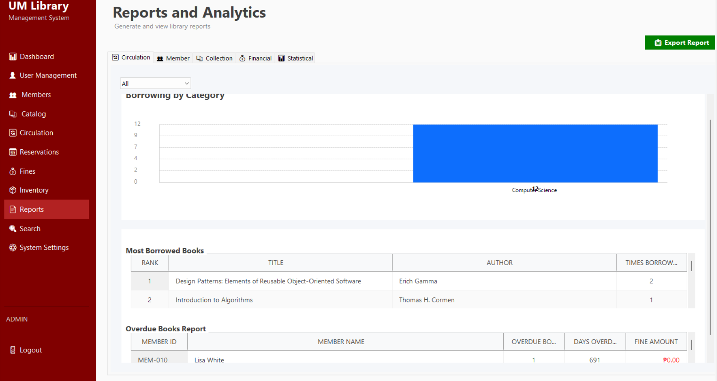
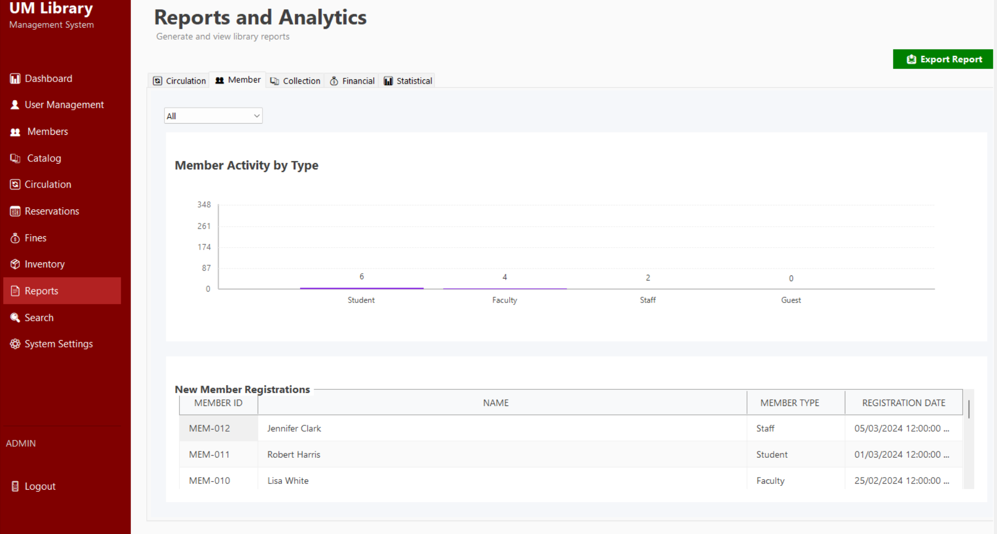
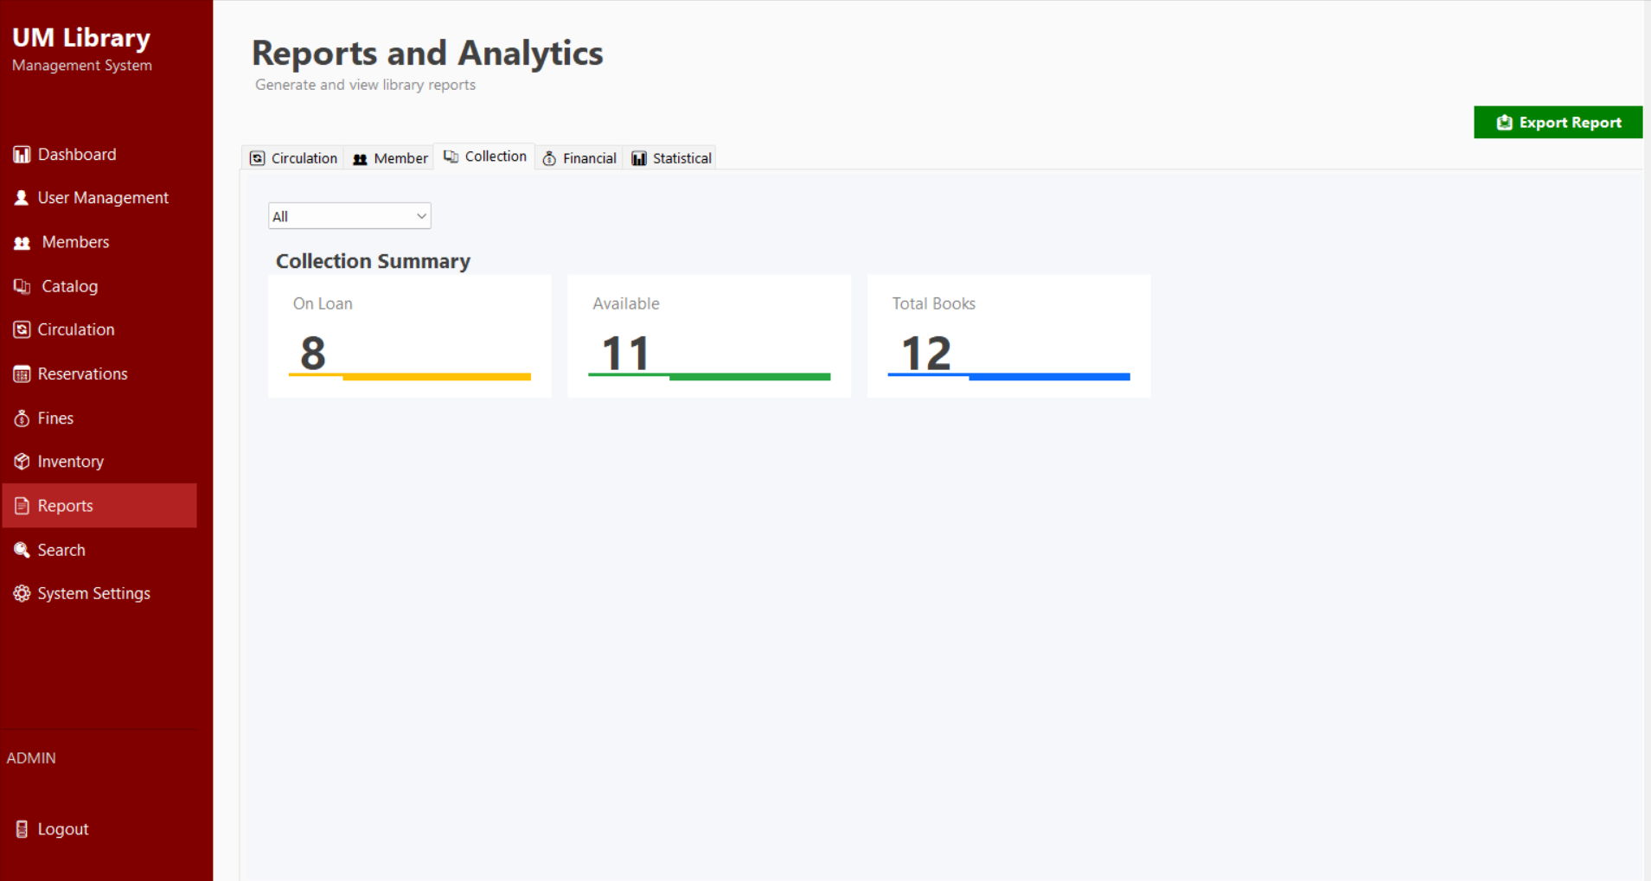
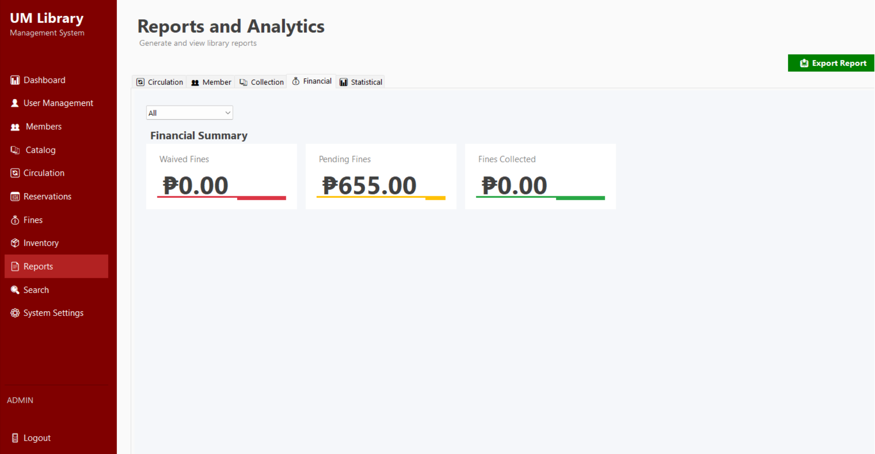
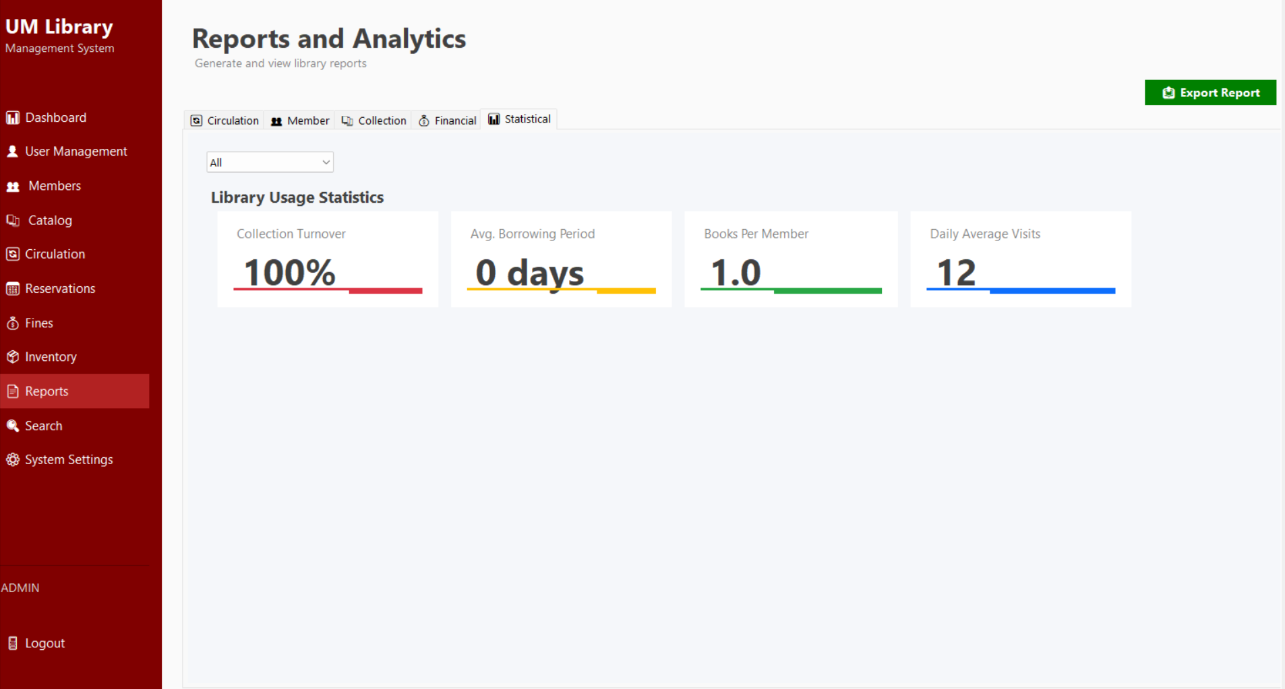
Figure 2.10 Admin Reports Page
Figure 2.10 Admin Reports and Analytics Page provides comprehensive insights into library operations through circulation, member, collection, financial, and statistical reports. It presents visual summaries and tabular data such as borrowing trends, member activity, collection status, fine summaries, and usage statistics, with an option to export reports to support monitoring, analysis, and informed administrative decision-making.

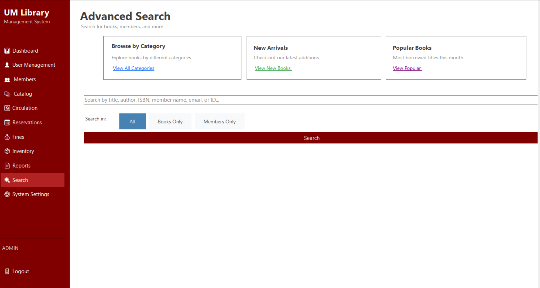
Figure 2.11 Admin Search Page
Figure 2.11 Admin Search Page provides a centralized advanced search interface for locating books, members, and related records. It supports searching by title, author, ISBN, member name, or ID, with options to filter results by books only, members only, or all records. The page also offers quick access to categories, new arrivals, and popular books, enabling fast and efficient information retrieval.

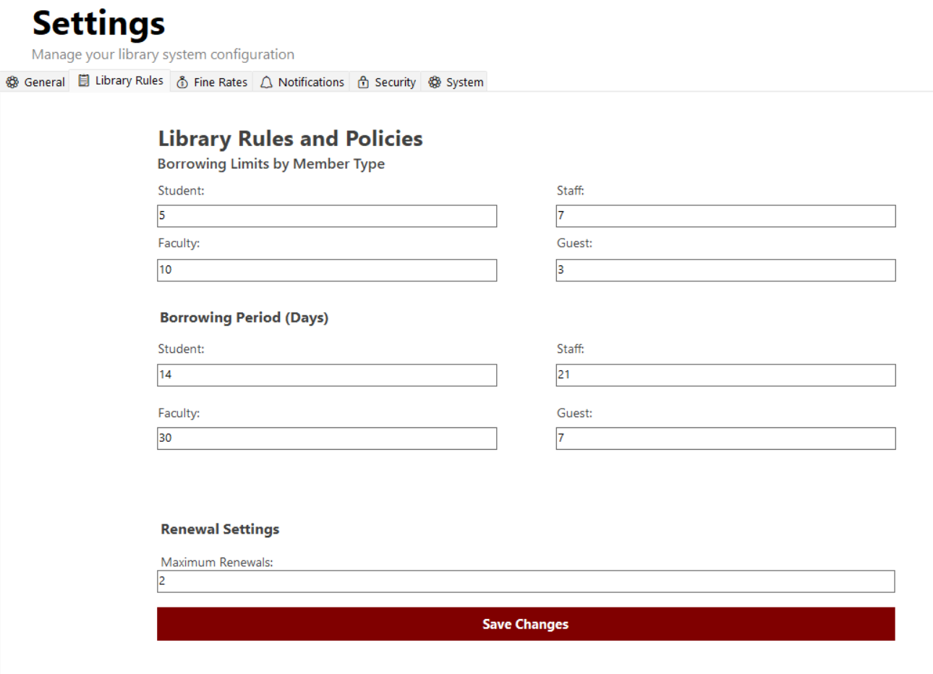
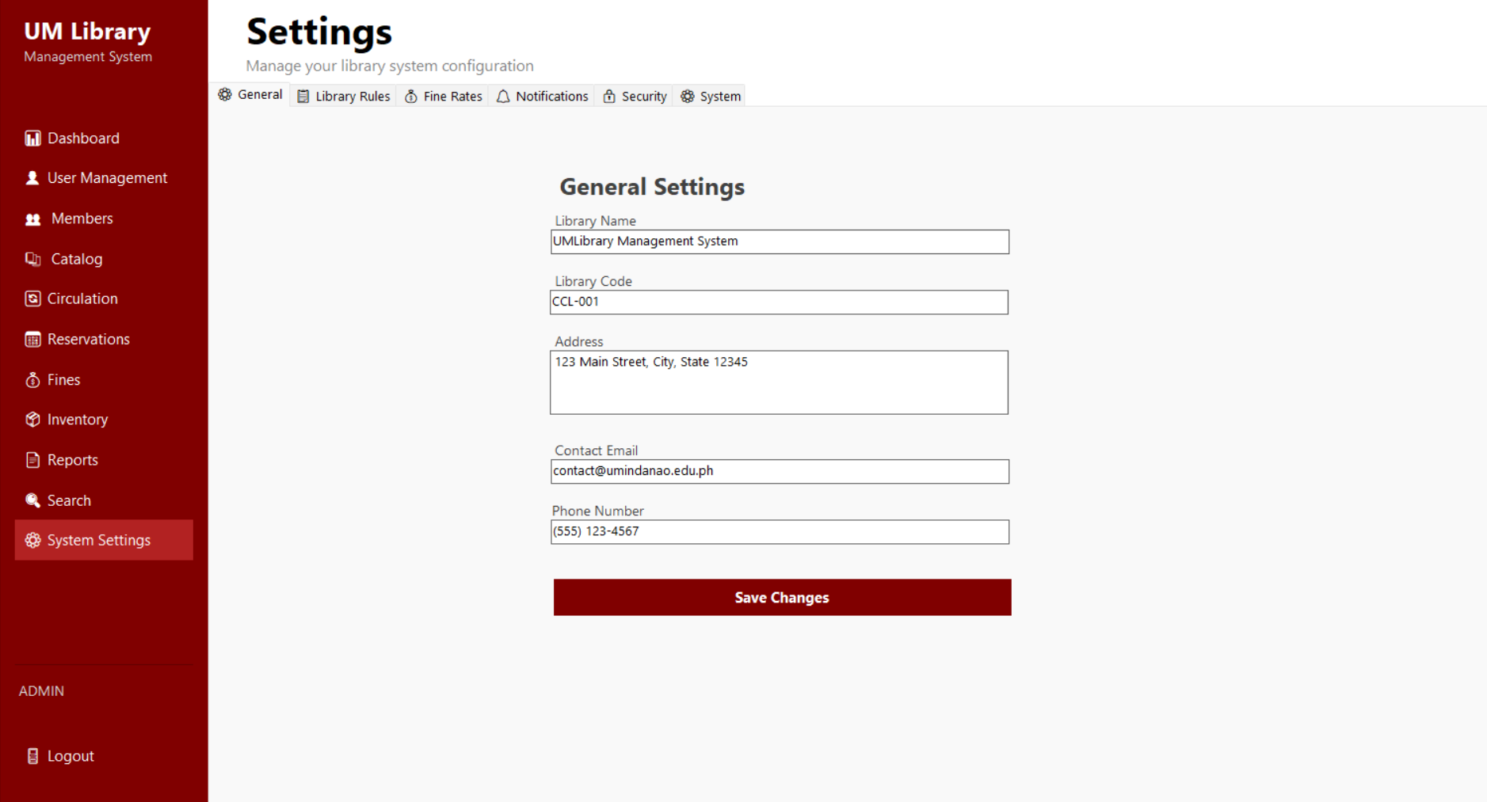
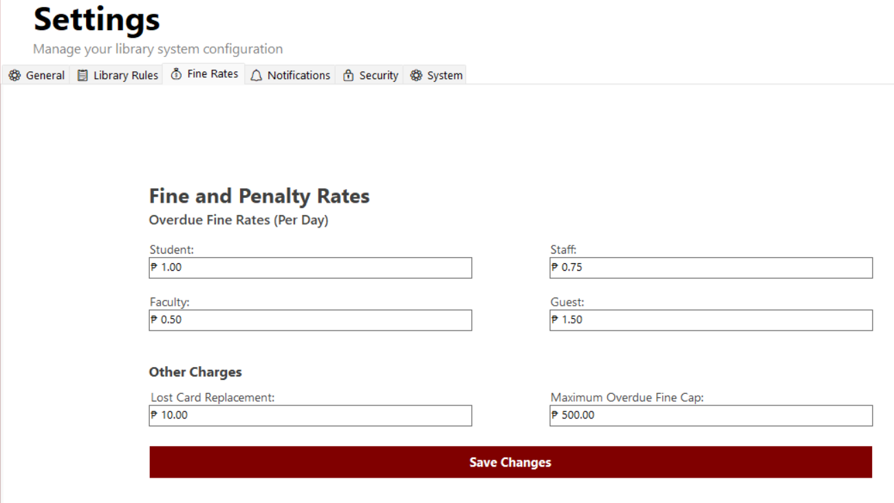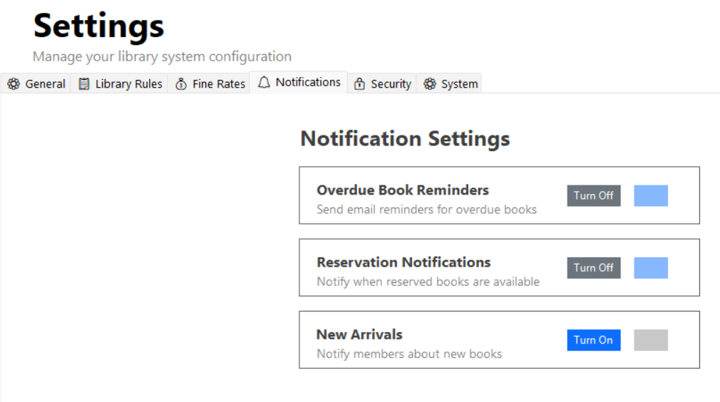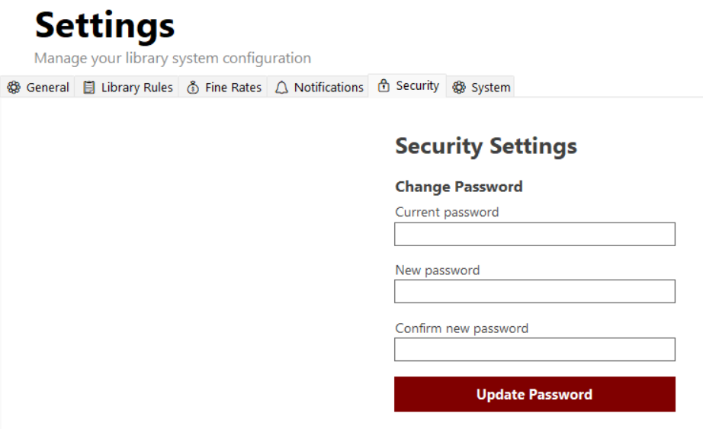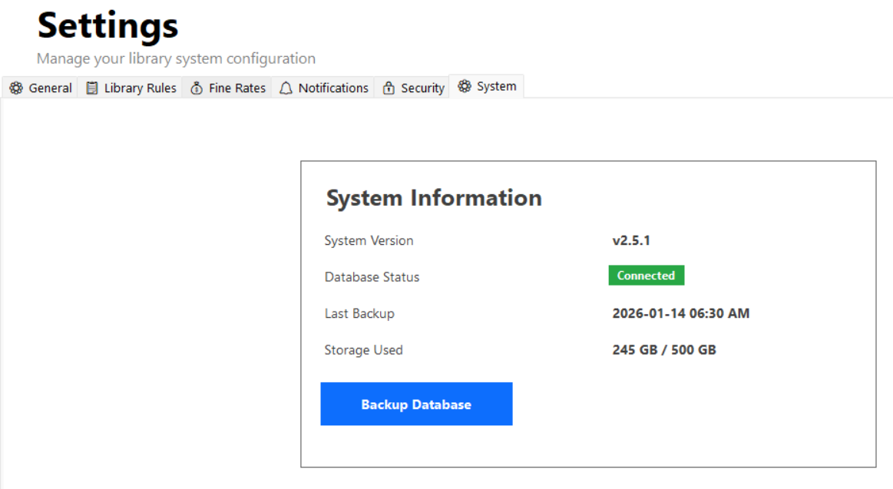Figure 2.12 Admin System Settings Page
Figure 2.12 Admin System Settings Page allows administrators to configure and manage system-wide settings of the Library Management System. It includes modules for general library information, borrowing rules and policies, fine and penalty rates, notification preferences, security settings, and system information. This page enables administrators to customize operational rules, update credentials, manage alerts, and monitor system status, ensuring proper configuration, security, and smooth system operation.

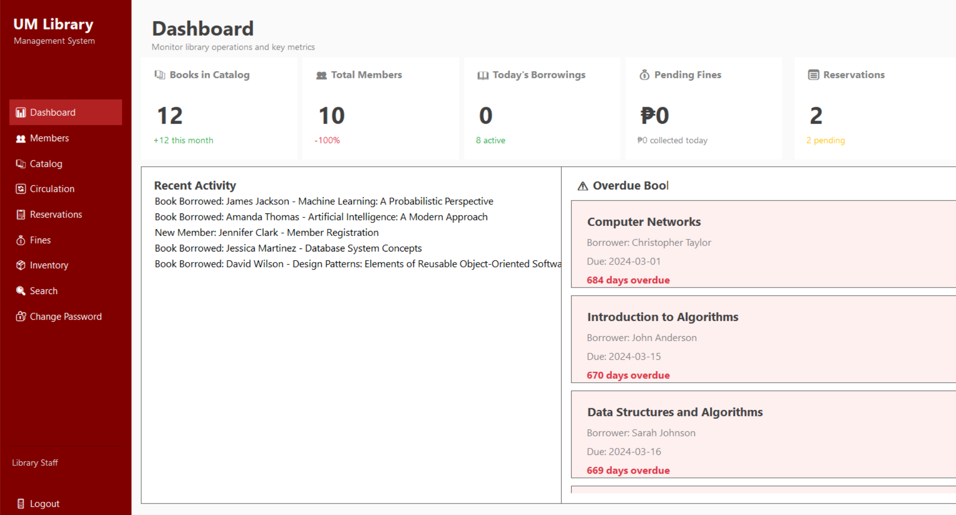
Figure 2.13 Library Staff Dashboard
Figure 2.13 Library Staff Dashboard provides library staff with a real-time overview of daily operations and key metrics, including books in the catalog, total members, today’s borrowings, pending fines, and reservations. It highlights recent activities and overdue books, enabling staff to quickly identify priority actions and efficiently support circulation and member services.

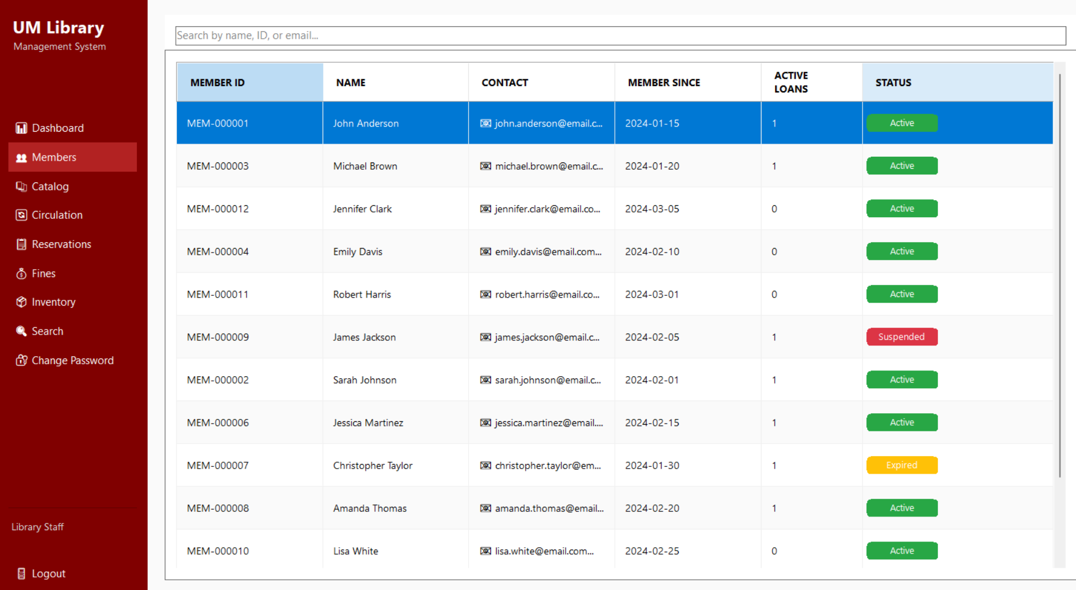
Figure 2.14 Library Staff Members Dashboard
Figure 2.14 Library Staff Members Dashboard displays a searchable list of registered library members for staff use. It presents key member information including member ID, name, contact details, membership date, active loans, and account status. This page enables staff to monitor member activity and status efficiently, supporting day-to-day circulation and member assistance tasks.

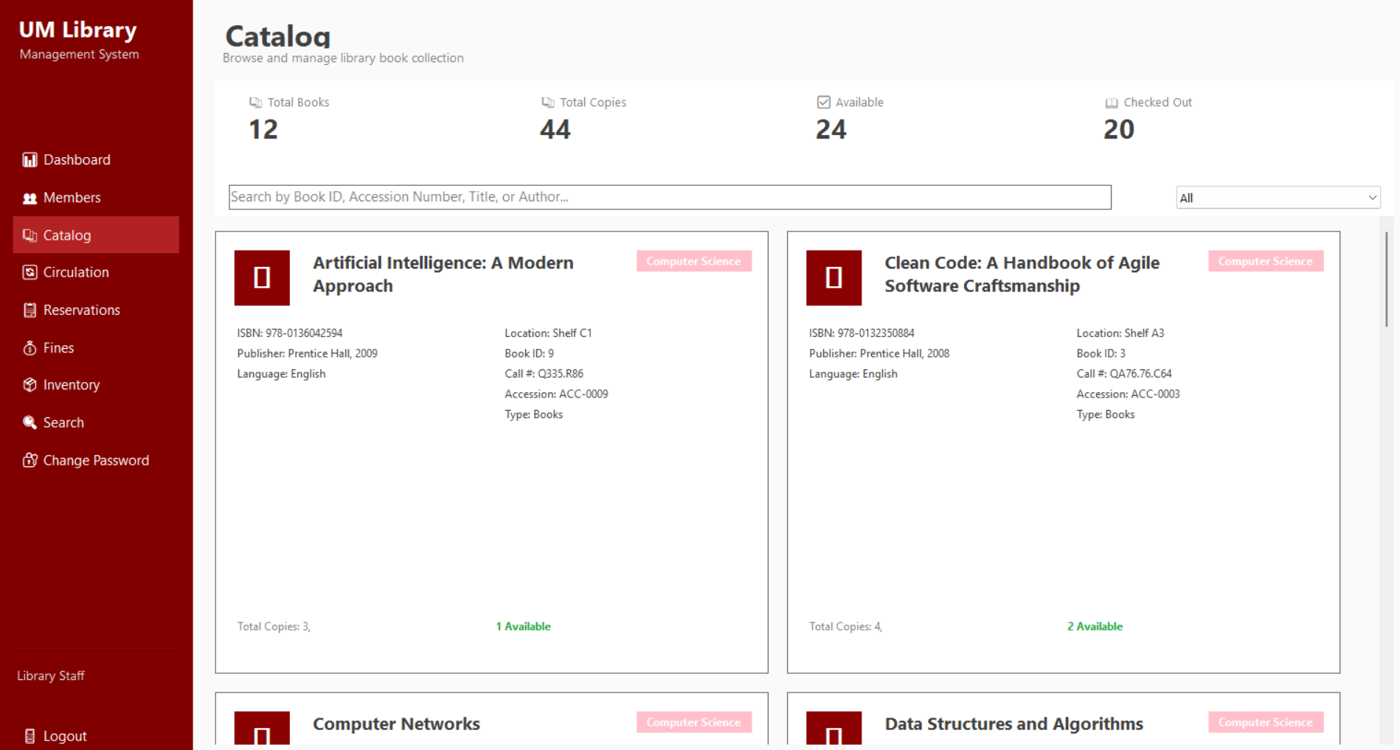
Figure 2.15 Library Staff Catalog Dashboard
Figure 2.15 Library Staff Catalog Dashboard allows library staff to browse and view the book collection. It displays summary indicators for total books, total copies, available items, and checked-out items, and presents detailed book cards with bibliographic information, location, accession details, and availability status. This page supports searching and filtering, enabling staff to quickly locate and assist with book-related inquiries.

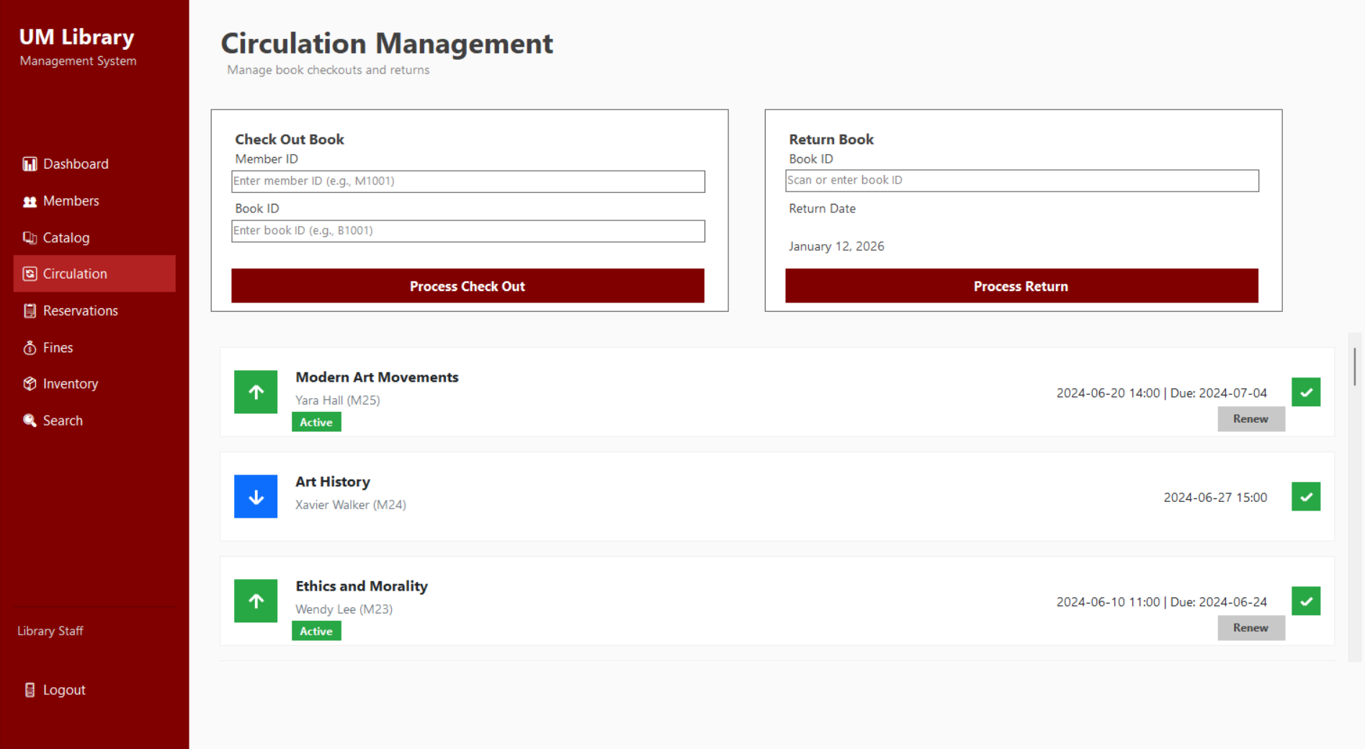
Figure 2.16 Library Staff Circulation Dashboard
Figure 2.16 Library Staff Circulation Dashboard enables staff to process book checkouts and returns efficiently. It verifies member eligibility, displays book availability, and automatically calculates overdue days and fines during returns. The page also includes a transaction history for tracking active, returned, and renewed items, supporting accurate and controlled circulation management.

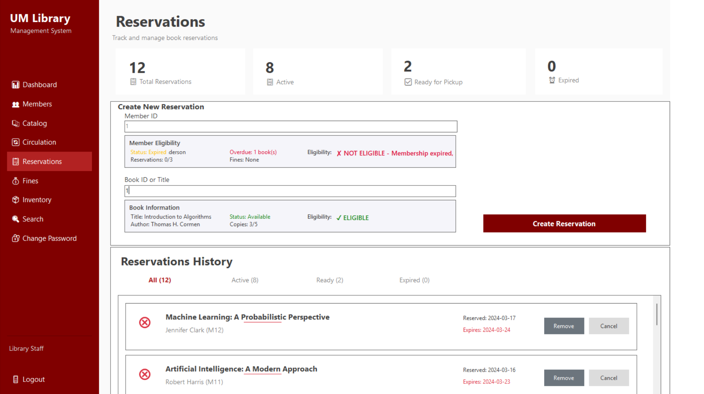
Figure 2.17 Library Staff Reservations Dashboard
Figure 2.17 Library Staff Reservations Dashboard allows staff to create, monitor, and manage book reservations. It validates member eligibility, displays book availability, and enforces reservation rules before processing requests. The dashboard also provides a reservation history with status tracking (active, ready for pickup, expired), enabling efficient reservation control and member assistance.

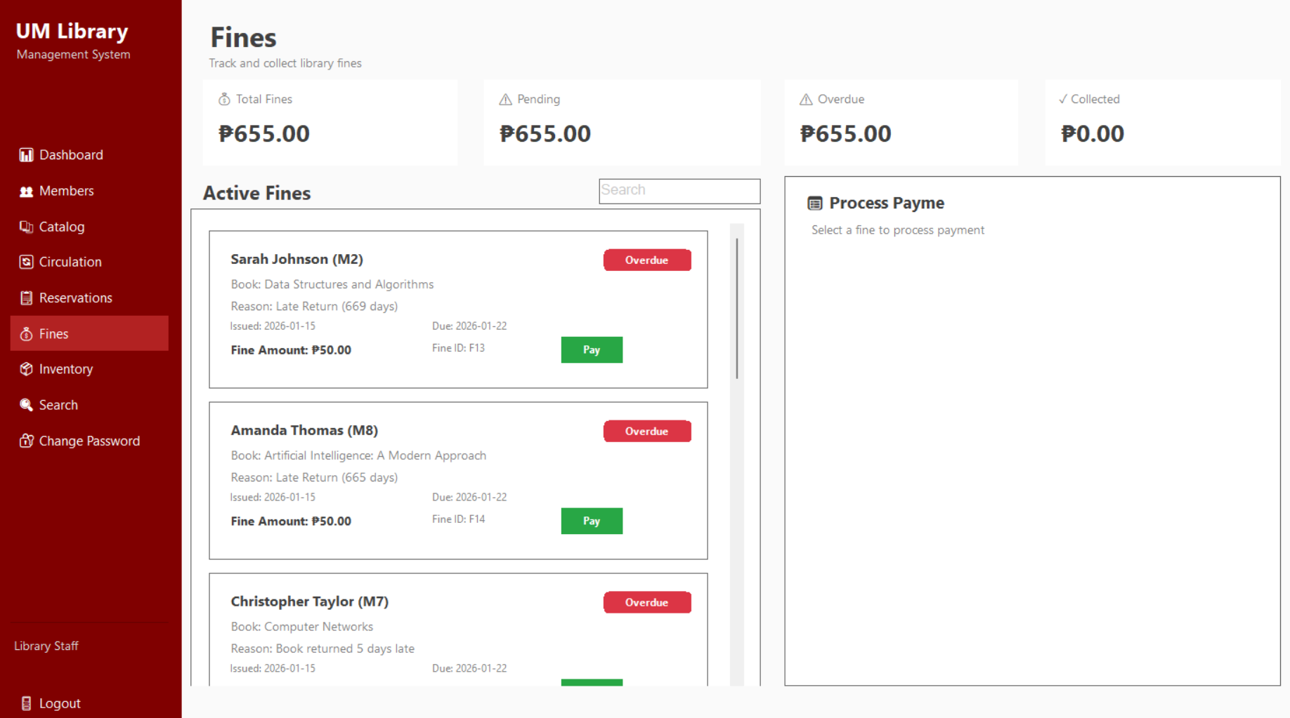
Figure 2.18 Library Staff Fines Dashboard
Figure 2.18 Library Staff Fines Dashboard enables staff to monitor, process, and collect library fines. It presents real-time summaries of total, pending, overdue, and collected fines, along with a list of active fines showing member details, violation reasons, and amounts due. The dashboard supports fine payment processing, automatically updating balances, statuses, and receipt records to ensure accurate financial tracking.

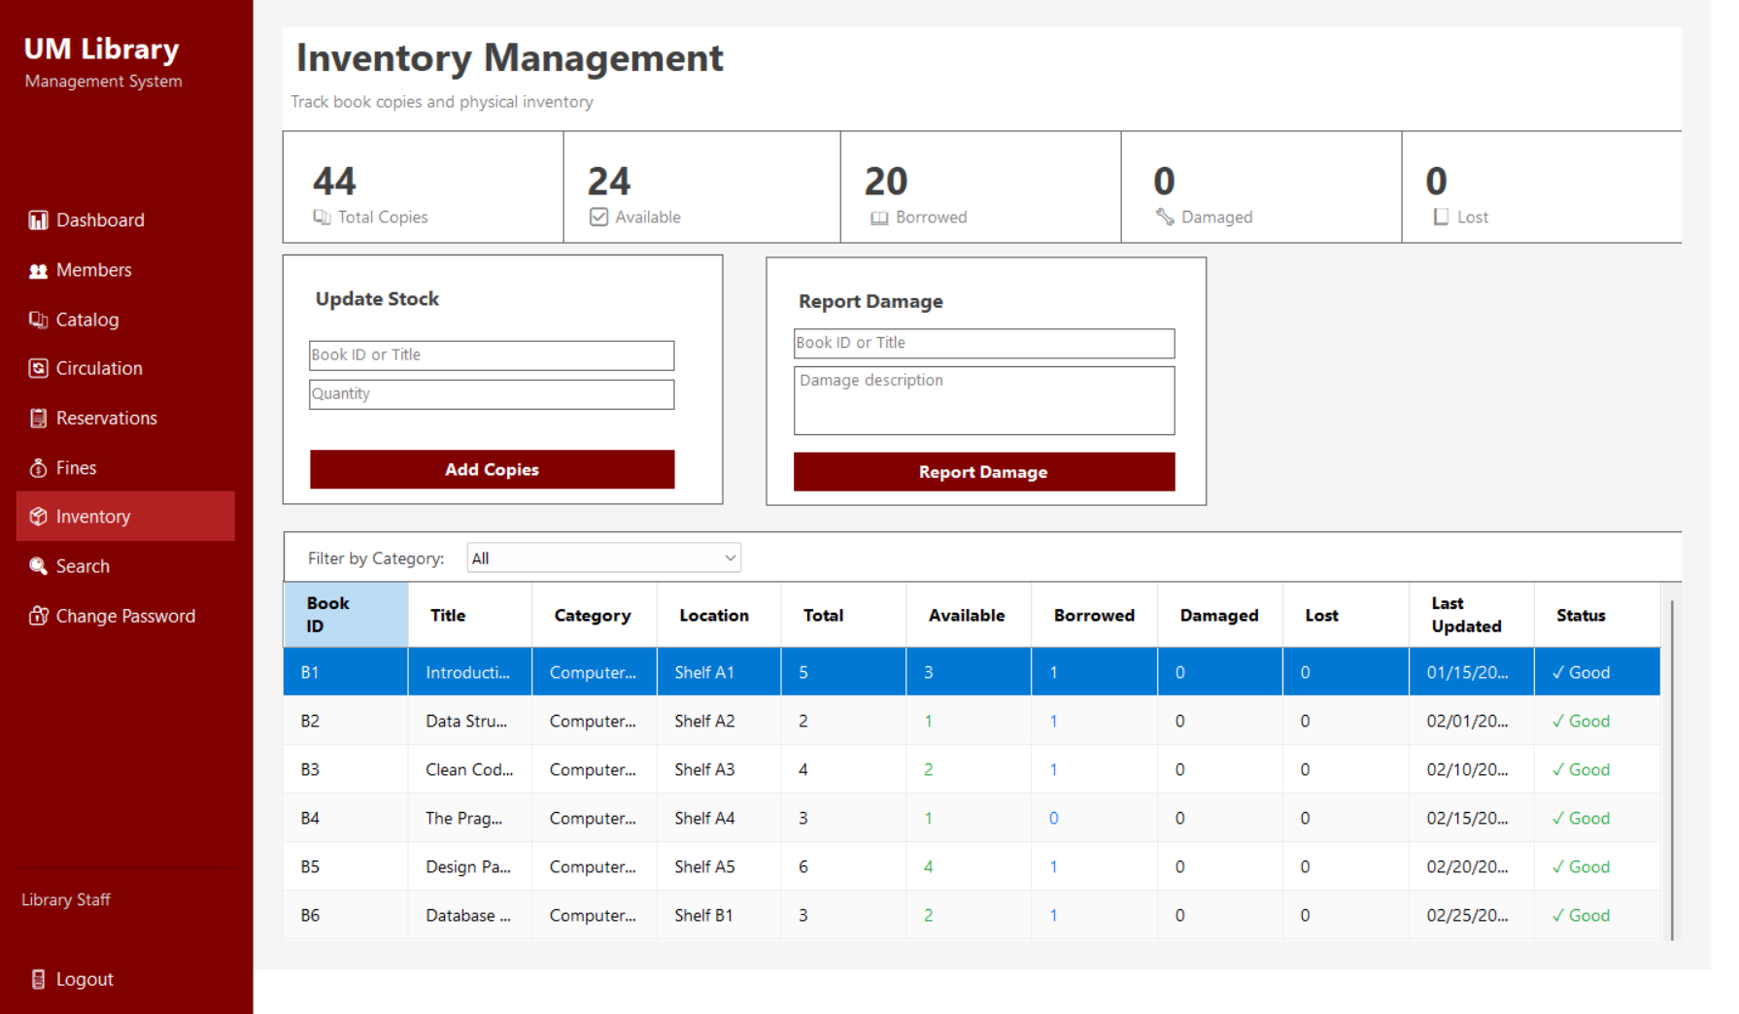
Figure 2.19 Library Staff Inventory Dashboard
Figure 2.19 Library Staff Inventory Dashboard enables staff to track and manage physical book copies. It provides real-time summaries of total, available, borrowed, damaged, and lost items, and allows staff to update stock levels, report damaged materials, and monitor inventory status by category and location, ensuring accurate and up-to-date inventory records.

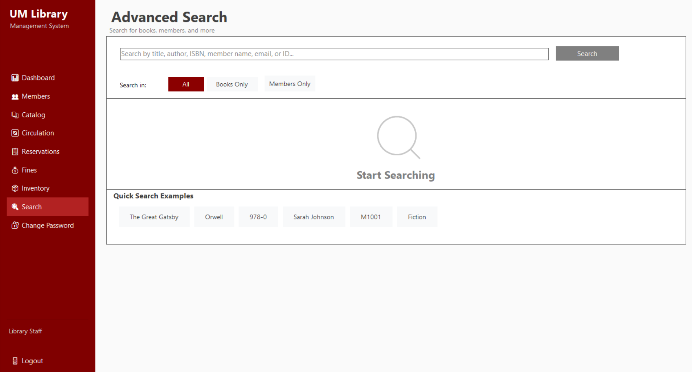
Figure 2.20 Library Staff Search Dashboard
Figure 2.20 Library Staff Search Dashboard provides an advanced search interface for locating books and member records. It supports searching by title, author, ISBN, member name, email, or ID, with scope filters for all records, books only, or members only. Quick search examples further assist staff in performing fast and accurate information retrieval.

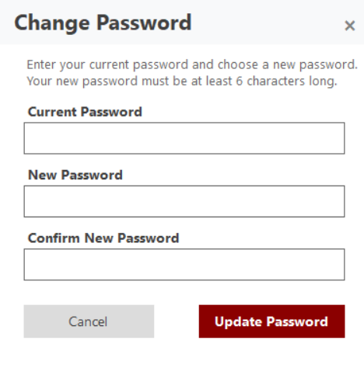
Figure 2.21 Library Staff Change Password
Figure 2.21 Library Staff Change Password shows a secure password update interface where staff enter their current password, set a new password, and confirm the change, ensuring account security through validation and minimum password requirements.

UML Class Diagram
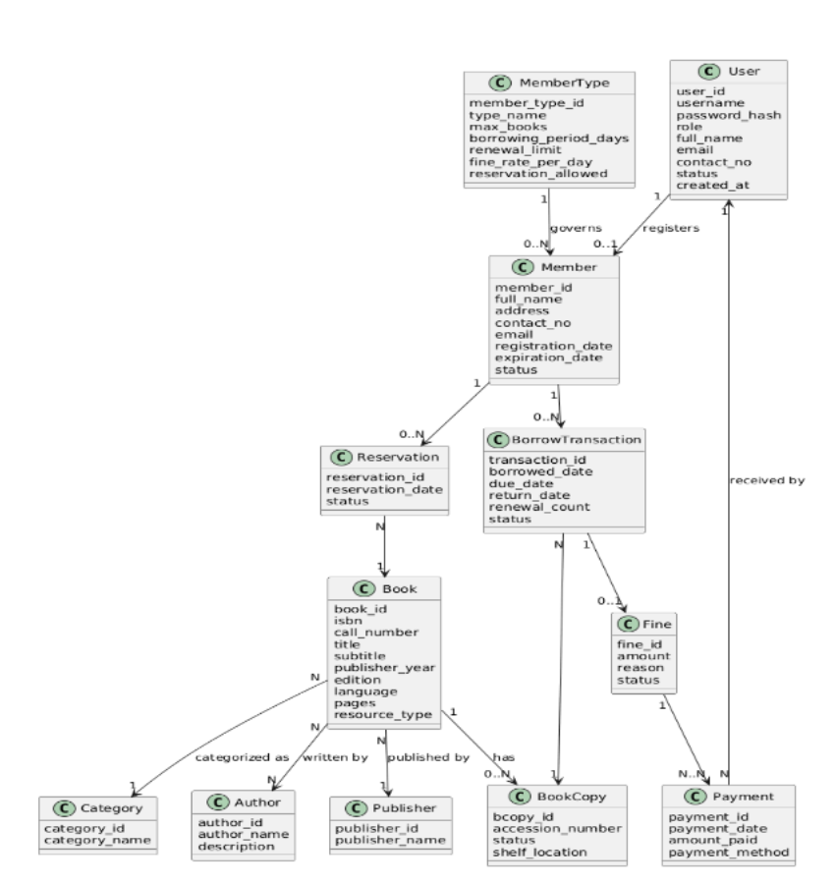
Figure 2.22 UML Class Diagram

Figure 2.22 UML Class Diagram presents the structural design of the Library Management System, showing key classes such as User, Member, Book, BorrowTransaction, Reservation, Fine, Payment, and BookCopy, along with their attributes and relationships. It illustrates how members borrow and reserve books, incur fines, make payments, and how books are categorized, authored, published, and managed by copy and inventory rules.

Use Case Diagram
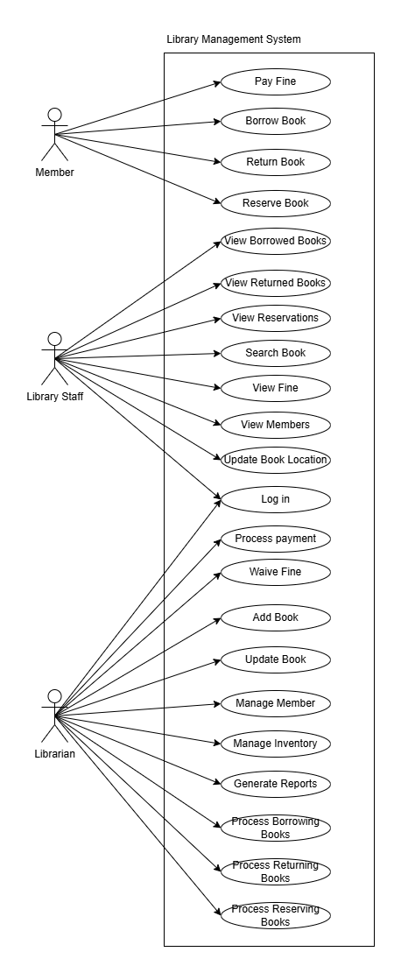

Figure 2.25 Use Case Diagram
Figure 2.25 presents the interactions between system actors—Member, Library Staff, and Librarian—and system functions. Each actor is restricted to predefined operations based on role, supporting controlled access and operational separation.

ERD (Entity Relationship Diagram)
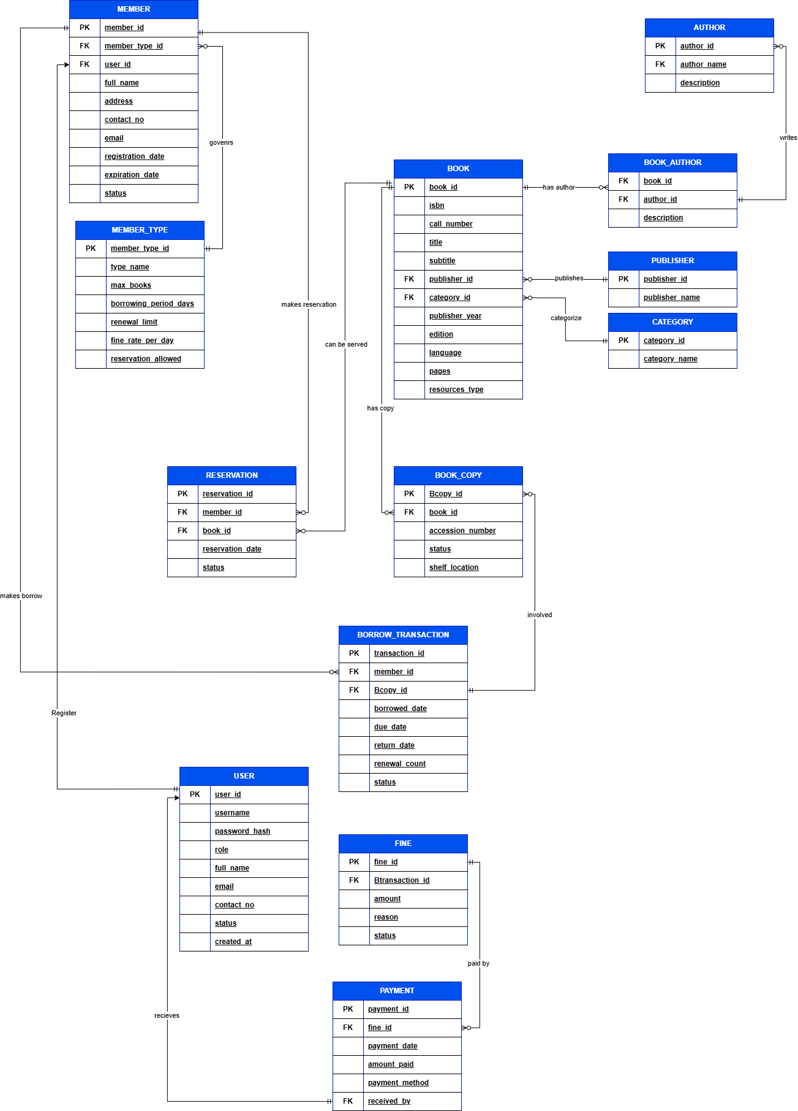

Figure 2.26 Entity Relationship Diagram
Figure 2.26 Entity Relationship Diagram presents the database structure of the Library Management System, showing key entities such as Member, User, Book, Book Copy, Borrow Transaction, Reservation, Fine, and Payment, along with supporting tables like Author, Publisher, Category, and Member Type. It illustrates how members borrow and reserve books, how fines and payments are recorded, and how book copies are managed, ensuring clear relationships and data integrity across the system.

CHAPTER 3

SYSTEM REQUIREMENTS

Functional Requirements
- Member Management: The system shall register members, assign unique Member IDs, classify members by type, and enforce borrowing limits, loan periods, renewal limits, and fine rates based on membership type.
- Catalog Management: The system shall allow authorized users to create, update, and delete book records with complete bibliographic metadata and manage multiple copies with individual accession numbers.
- Circulation Management: The system shall process borrowing, returning, and renewal transactions by validating member eligibility, copy availability, and policy compliance.
- Reservation Management: The system shall allow eligible members to reserve books and track reservation status while preventing invalid requests.
- Fine and Payment Management: The system shall compute overdue fines based on configured rates and record payments with corresponding status updates.
- Inventory Management: The system shall track book copies by availability, condition, and location, and support reporting of damaged or lost items.
- Reporting and Analytics: The system shall generate circulation, inventory, member, and financial reports for administrative review.

Non-Functional Requirements

- Security:
Access Control
The system shall enforce role-based access control, allowing only authorized roles to access administrative functions such as fine waivers, report generation, and inventory updates.
Authentication
All users shall authenticate using registered credentials. Passwords shall be stored using secure hashing techniques.
- Performance:
Response Time
The system shall process searches, transactions, and dashboard updates without data loss or transaction conflicts during normal usage.
Transaction Processing
All circulation, fine, and payment transactions shall be executed atomically to prevent partial updates.
- Reliability:
Data Consistency
Updates to circulation, fines, inventory, and member records shall remain synchronized across all modules.
Error Handling
The system shall display clear system messages for invalid inputs, failed transactions, and policy violations (e.g., expired membership, overdue limits reached).
- Usability:
User Interface Consistency
All system interfaces shall follow a consistent layout and navigation structure.
Role-Specific Display
Menus and features shall be displayed based on the user’s assigned role.
- Maintainability:
Configuration Management
Borrowing rules, fine rates, and renewal limits shall be configurable through system settings without source code modification.

References

American Library Association. (2020, December 15). Library privacy guidelines for library management systems. https://www.ala.org/advocacy/privacy/privacyguidelines/lms
Araya, A. T., & Mengsteab, T. H. (2020). The role of library management systems in modern library operations. International Journal of Research in Library Science, 6(1), 1–15.
F.L. Vargas College (Pinto, J. M.). (2024). Efficient library solutions: Developing a library management system for FL Vargas College. AIDE Interdisciplinary Research Journal, 8(1), 174–181. https://doi.org/10.56648/aide-irj.v8i1.119
Martin, R. C. (2003). Agile software development: Principles, patterns, and practices. Prentice Hall.
Soutron. (2020, June 28). 5 reasons libraries need library management systems. https://www.soutron.com/blog/general/5-reasons-libraries-need-library-management-systems/
Zunjar, S., Yadav, R., & Markad, R. (2020). Library management system. International Journal of Engineering and Techniques, 6(4)

